Smart Sensor Simulator Theory of Operation

# Overview

The Smart Sensor Simulator (SSS) is a device design to emulate the sensors a heavy vehicle electronic control module (ECM) is looking for in a key-on, engine-off (KOEO) condition. Sometimes data on heavy vehicle ECMs can be downloaded as part of a crash investigation. Obtaining and preserving this date is important in a forensic context because ECMs when turned on after an event may have fault code data that is overwritten if the sensors are not electrically present. A potential solution would be to build individual sensor harnesses for each type of ECM using actual sensors; however, that approach is cost prohibitive if it were to scale.

# Design Requirements and Goals

The design goals of the Smart Sensor Simulator is to be a cost effective solution to communicating with heavy vehicle ECMs while being able to adjust the simulated outputs. The types of signals that are needed to be generated are as follows:

* Switches to Ground
* Resistors to Ground
* Resistors to +5V
* Resistors to +12V
* Voltage signals
* Resistors between two ports
* Pulse width modulated (PWM) signals
* Controller Area Network signals to produce J1939 messages
* Ignition key signal

Furthermore, these interfaces need to be robust and protected. The design should be universal to as many different manufacturers as possible.

## Enclosure and Interfaces

For a rugged and professional implementation, a blue anodized aluminum enclosure was selected to house the SSS circuit card assemblies. This enclosure is made by Hammond Manufacturing and bears the part number 1455T2201BU. This enclosure provides capacity for a printed circuit board that is 6.3 inches wide. Interfacing with the ECMs requires building cable assemblies with the correct ECM mating connector. This is a specific implementation issue, so the details regarding those parts are left to the descriptions of the specific implementations. However, the cable assemblies interface with the SSS board using a common solution, namely the Molex Mini Fit Jr. Series board to wire connectors. In this series, the width of the board can accommodate a 24-pin, 16-pin, 18-pin, and 10-pin board to wire right angle pin housing as shown on the left side of Figure 1.

On the other side of the SSS, a common assembly that contains the user interfaces, buttons, 9-pin J1939 diagnostic port, USB port, and LED indicators are present. The interface from this panel assembly to the SSS printed circuit board is made with a 12-pin Molex Mini Fit Jr connector on the top middle of Figure 1. The opening in the circuit board to the left of the 12 position connector is to accommodate the flanges of the mating connector.

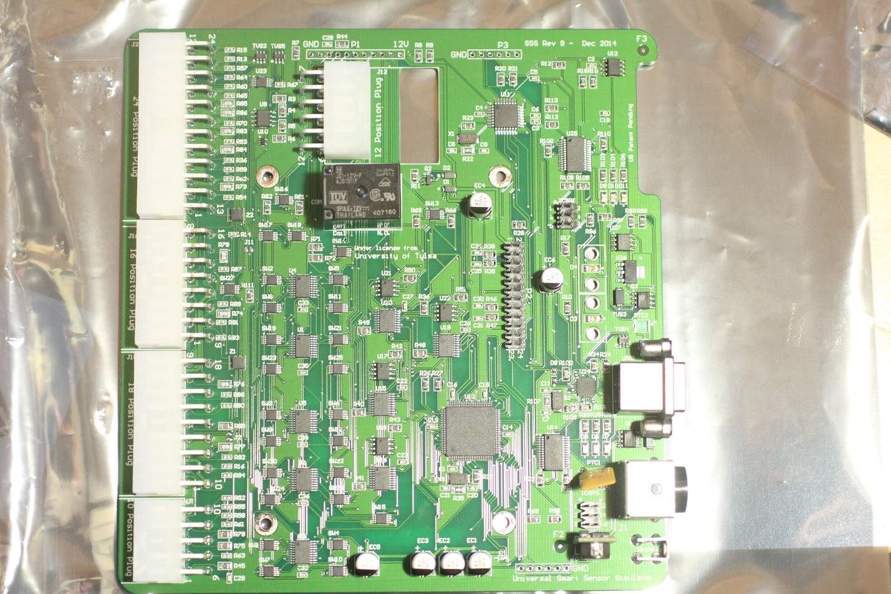

Figure 1: Smart Sensor Simulator Main Circuit Card Assembly (revision 9).

Since all the interfacing wires use the same crimp system, the economies of scale help keep the wiring costs down. Also, each connector is different, which makes each wire end unique when populating cavities. The wiring can only be plugged into the board the correct way.

# Main Board Design

The main board in the SSS is present in all implementations. It serves the function of operating the user interfaces, like lights and buttons, as well as controlling all of the sensor simulating devices. The best way to describe electronics is through the schematics used to design and build the device. As such, this section will contain the detailed description of the schematic diagram for the Smart Sensor Simulator Main Board, Revision 10.

## Power Management

The power entry has two sources. The main power entry port is J1, which is a 4-pin locking connector. It interfaces with a Meanwell GS120A12-R7B desktop power supply without modification. It is a through hole board mount connection that accepts 12V DC on Pins 1 and 3 with Ground being connected to Pins 2 and 4. The current coming into the device first passes through a Positive Temperature Coefficient (PTC) resistor that acts as a resettable fuse in case any component on the downward side were to experience a short circuit. Additional protection from transient voltages, like static electricity, is provided by the transient voltage suppressor (TVS) diode, Z3. These TVS diode are use throughout the SSS on externally facing ports.



Figure 2: Power input schematic for the SSS.

The port J4 is internal to the SSS and is designed to accept power from a pigtail connection. The 4 port connector is 2 rows by 2 columns. This way the wiring will work if the positive and ground connector is in a row or column, but not diagonal.

Port J3 is intended to supply power to additional modules or to a daughter board for additional current carrying capacity. Often this port is not used.

The electrolytic capacitors provide filtering and energy reserve.

 

Figure 3: Power path switching on the left and voltage regulation on the right.

The integrated circuit U28 is a dual path power controller that is designed to enable power to pass through a P-Channel MOSFET device depending on the priority or preference of the device. This enables graceful switching between power supplies when connected. For example, the Meanwell desktop power supply is providing power through port J1 and energizing the 12V0 electrical net. At the same time, a battery is connected by connecting a cigarette lighter adapter to an inline cable connected to the SSS board through port J4. If the power supply is unplugged from the wall, then the power controller U28 switches over to the battery backup. Once AC to DC power is restored, the battery is shut off, and normal powering proceeds.

This redundant powering method should keep the Safe 12V net consistently powered. This 12 V provides the energy needed to power the 5V circuits through the regulator U6, which is used for the majority of all the rest of the components. An LED, which is displayed on the front panel as Power, is lighted when Vcc is present.



Figure 4: Current limiting circuit.

The Safe 12V is also isolated through an inrush (outrush) current limiting negative temperature coefficient (NTC) resistor and a Schottkey diode. The current limiting resistor is to keep the SSS from experience too severe of transients when cycling power from off to on when connected to an ECM. Some ECMs have a lot of capacitance and those capacitors act like short circuits when initially powered on. An NTC starts with a nominal resistance (say 10 ohms), then resistance decreases as current flows and heats up the NTC. At the same time, the capacitors are charging in the ECMs and the initial short circuit equivalent condition is no longer present. The Schottkey diode prevents reverse polarity conditions and ensures the proper direction of current flow. About 0.3 volts are dropped across this diode junction. This improves the reliability of the SSS when turning the ignition from on to off.

## Primary Microcontroller

The schematic shown in Figure 5 was inspired by the Arduino Pro Mini and Arduino Uno circuit designs. The Atmel ATMega328P microprocessor is powered by the 5V regulator and runs at 16 MHz. The ICSP header is available to upload programs and flash the boot loader using either the Arunino IDE or Atmel’s AVR Studio. A serial debugging and interface (not shown) is also available. It uses the hardware UART block to communicate with the ATMega using Pins 31 and 30. The capacitor C5 provides a coupling between the reset button and the serial communication module through the DTR line. A UART device may have access to a DTR line and can toggle it to reset the microprocessor. This enables easy programming of the microprocessor.



Figure 5: ATMega328P 8-bit microprocessor

The microprocessor controls the ignition relay shown in Figure 6. A user will depress the button on the front panel and pull Pin 11 of U11 high. Since this is a noisy mechanical button, a de-bounce delay of 2 seconds is used to delay the toggling of the relay state. The relay is driven by a logic high on pin 12 of U11. This is applied to the high impedance gate of the specialized N-Channel MOSFET (N-FET) that is designed to drive inductive loads. This high level on the N-FET enables a path to ground for current flowing though the relay coil. This energizes the coil and closes the contacts. The program on the microcontroller also illuminates D3 from U11 Pin 9 so the user can see that the key is now in the on position.



Figure 6: Ignition Relay.

The SDA and SCL ports are pulled high to enable I2C communications. Pins 15, 16, and 17 comprise the SPI master pins with chip select pins being available on A0 and A1.

## Digital to Analog Signals

A quad channel 12-bit digital to analog converter (DAC) is available over the I2C bus with a slave address of 0x61. The DAC is capable of creating arbitrary voltages as defined by the digital commands. However, in all the implementations so far, the DAC is just used to generate a fixed voltage value. The outward facing ports are Vout A, Vout B, Vout C, and Vout D. Since these can sometimes have uncontrolled loads or shorts applied, U25 is protected by current limiting 100 ohm PTCs and a TVS diode array. The voltage out is limited between 0 and 5 volts. However, the unit can both sink and source current.



Figure 7: Digital to Analog Converter with circuit protection.

## Output Ports

The output ports that are connected to the ECMs are defined the following figures. In the previous section, the Vout X ports were described. In addition, the available ports can be grouped by function as follows:

* Power, Ground, Ignition, Supplies and Returns
* Controller Area Network (CAN)
* J1708 network
* K-Line or LIN communications
* Coils
* Potentiometers (Un-PxW, where n is the chip number and x is the potentiometer tap indicator)
* PWM
* Resistors

The fixed resistors are point to point as shown in the left side of



Figure 8: Connection port definitions for the Molex connectors on the left side of Figure 1.



Figure 9: Connector for the common front panel with the J1939 diagnostic connector.





Figure 10: Selectable fixed resistances with a relay.

# Daughter Board Design

# Microprocessor Code